
North Bengal International University

Lab Report: 02

Exp Name : Bubble sort Algorithm

Subject : Analysis of algorithm Sessional
Subject Code : CSE 0612-2212

Submitted By:
Name : Md. Tanvir Rahman Pranto
Dept : CSE(26)
Roll : 0712340012101005
Semester : 3rd Year, 5th semester.

Submitted To:
Name : Afsana Tasnim
Designation : (HOD)Lecturer
Dept : CSE
Date :

Task No: 01
Task Name: Bubble sort
Introduction: Bubble sort is a simple, comparison-based, in-place sorting algorithm that repeatedly passes through a list, compares adjacent items and swaps them if they are in the wrong order. Over repeated passes the largest (or smallest) elements "bubble" to their final positions.
Algorithm:
- Start with the full array.
- Compare the first and second elements. If they are out of order (depending on ascending/descending), swap them.
- Move one position right and compare the next adjacent pair; swap if needed.
- Continue steps 2–3 until you reach the end of the array — after this first pass the largest element will be at the end.
- Repeat passes over the array, but each time ignore the last element(s) that are already sorted (reduce the effective length by 1).
- Optionally: if a full pass makes no swaps, the array is already sorted — stop early (optimization).

Pseudocode:
bubbleSort(A[0..n-1])
read Array← from user
for i from 0 to n-2 do
if A[i] > A[i+1] then
swap A[i] and A[i+1]
swapped ← true
end if
end for
n ← n - 1
until not swapped
end

code:
#include <stdio.h>

int main() {
int n, i, j, temp;
int swap;

printf("Enter the number of elements: ");
scanf("%d", &n);

int arr[n];

printf("Enter %d elements: ", n);
for (i = 0; i < n; i++) {
scanf("%d", &arr[i]);
}

printf("\nBefore sorting: ");
for (i = 0; i < n; i++) {
printf("%d ", arr[i]);
}
printf("\n");

for (i = 0; i < n - 1; i++) {
swap = 0;
for (j = 0; j < n - i - 1; j++) {
if (arr[j] > arr[j + 1]) {
temp = arr[j];
arr[j] = arr[j + 1];
arr[j + 1] = temp;
swapped = 1;
}
}
if (swap == 0) {
break;
}
}

printf("After sorting: ");
for (i = 0; i < n; i++) {
printf("%d ", arr[i]);
}
printf("\n");

return 0;
}

output:
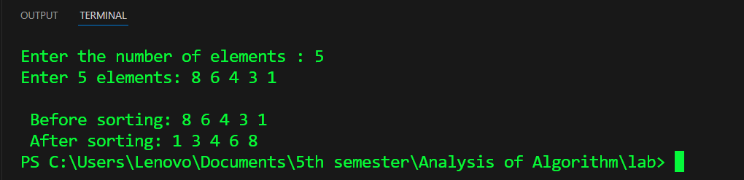
Time complexity: Worst/Average = O(n²), Best (already sorted with early stop) = O(n).

Conclusion: Bubble Sort is a simple sorting algorithm that repeatedly compares and swaps adjacent elements until the list becomes sorted. Though it is easy to understand and implement, its time complexity is O(n²), which makes it inefficient for large datasets. However, it is useful for learning the basics of sorting techniques and works well for small arrays.

